**Metaphor/Architecture Specification Template**

|  |  |  |  |  |
| --- | --- | --- | --- | --- |
| Student | Javier Mesa | | Date | 02/04/2017 |
| Program | PSP2 | Program # | 5 | |
| Instructor | Mario Riveros | Language | Java | |

|  |  |
| --- | --- |
| **Design**  **References** | Functional Specification |
| Operational Scenarios |
| State Specification |
|  |  |
|  |  |

**Graphical representation of the metaphor**

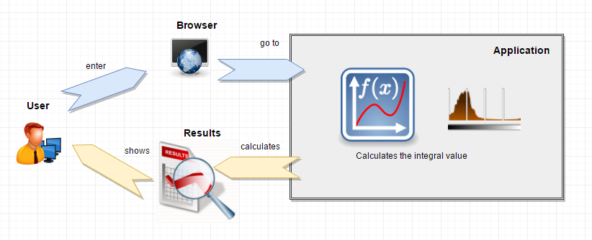

**Textual representation of metaphor**

The user enters opens a window of his preferred browser, and writes the url of the application, enters the parameters of ***x from***, ***x to*** and ***dof***. The application makes the necessary calculations and prints on the page the expected value for the values you enter and the user is happy with the result.